Regulatory Committee
Meeting to be held on 15 March 2018

Electoral Division affected:
Wyre Rural Central

Wildlife and Countryside Act 1981
Definitive Map Modification Order Investigation
Addition of Footpath from Lancaster Road to Public Footpath 19, Pilling, Wyre Borough
File No. 804-459
(Annex ‘A’ refers)

Contact for further information:
Claire Blundell, 01772 533196, Paralegal, Legal and Democratic Services,
Claire.blundell@lancashire.gov.uk
Jayne Elliott, 07917 836626, Public Rights of Way Officer, Planning and Environment Jayne.elliott@lancashire.gov.uk

Executive Summary

Application for the addition to the Definitive Map and Statement of a footpath from Lancaster Road, Pilling to Public Footpath 19 Pilling, Wyre Borough, in accordance with File No. 804-459.

Recommendation

- That the application for a Footpath from Lancaster Road, Pilling to Footpath 19 Pilling, to be added to the Definitive Map and Statement of Public Rights of Way, in accordance with File No. 804-459 be accepted.
- That an Order be made pursuant to Section 53 (2)(b) and Section 53 (3)(b) and Section 53 (c)(i) of the Wildlife and Countryside Act 1981 to add a Footpath from Lancaster Road, Pilling to Footpath 19 Pilling to the Definitive Map and Statement of Public Rights of Way as shown on Committee Plan between points A and E.
- That being satisfied that the higher test for confirmation can be met the Order be promoted to confirmation.

Background

An application under Schedule 14 of the Wildlife and Countryside Act 1981 has been received for the addition of a footpath from Lancaster Road, Pilling to Footpath 19 Pilling, shown on the Committee plan between point A and point E on the Definitive Map and Statement of Public Rights of Way.

The County Council is required by law to investigate the evidence and make a decision based on that evidence as to whether a public right of way exists, and if so its status. Section 53(3)(b) and (c) of the Wildlife and Countryside Act 1981 set out the tests that need to be met when reaching a decision; also current Case Law needs to be applied.

An order will only be made to add a public right of way to the Definitive Map and Statement if the evidence shows that:
- A right of way “subsists” or is “reasonably alleged to subsist”

An order for adding a way to or upgrading a way shown on the Definitive Map and Statement will be made if the evidence shows that:
- “the expiration… of any period such that the enjoyment by the public…raises a presumption that the way has been dedicated as a public path or restricted byway”

When considering evidence, if it is shown that a highway existed then highway rights continue to exist (“once a highway, always a highway”) even if a route has since become disused or obstructed unless a legal order stopping up or diverting the rights has been made. Section 53 of the Wildlife and Countryside Act 1981 (as explained in Planning Inspectorate’s Advice Note No. 7) makes it clear that considerations such as suitability, the security of properties and the wishes of adjacent landowners cannot be considered. The Planning Inspectorate’s website also gives guidance about the interpretation of evidence.

The County Council’s decision will be based on the interpretation of the evidence discovered by officers and documents and other evidence supplied by the applicant, landowners, consultees and other interested parties produced to the County Council before the date of the decision. Each piece of evidence will be tested and the evidence overall weighed on the balance of probabilities. It is possible that the Council’s decision may be different from the status given in any original application. The decision may be that the routes have public rights as a footpath, bridleway, restricted byway or byway open to all traffic, or that no such right of way exists. The decision may also be that the routes to be added or deleted vary in length or location from those that were originally considered.

Consultations

Wyre Borough Council have been consulted and confirmed that they have no comments to make.

Pilling Parish Council supports the application stating that the route has been used for many years.

Applicant/Landowners/Supporters/Objectors

The evidence submitted by the applicant/landowners/supporters/objectors and observations on those comments are included in Advice – Head of Service – Legal and Democratic Services Observations.

Advice

Head of Service – Planning and Environment

Points annotated on the attached Committee plan.

Point | Grid Reference (SD) | Description
A | 4121 4717 | Open junction with Lancaster Road
B | 4114 4739 | Application route leaves access road adjacent to bridge over Ridgy Pool
C | 4115 4740 | Pedestrian gate
D | 4117 4742 | Pedestrian gate
E | 4118 4744 | Junction with Footpath 19 Pilling

Description of Route

The application was made in 2006 and a site inspection carried out in November 2007.

The Investigating Officer who carried out the site inspection has since retired but noted the following:

The route commenced on Lancaster Road, immediately to the east of Clow’s Bridge (point A on the Committee plan). It passed over a mixed-surface access road in a generally good condition and in regular use by vehicles. The access road was bounded by a hedge and fence to the east and a grass bank leading down to the dyke known as Ridgy Pool to the west. The route followed the access road for approximately 235 metres passing the derelict Brook Hall farm and Brookside Cottages.

At point B the route then turned north east where there was a stoned area of land to the north side of No. 2 Brookside Cottages running up to a high cement rendered boundary wall with a strip of grass, 2 – 2.5m wide alongside the wall. The Officer carrying out the inspection noted that the wall looked as if it had recently been built or rebuilt as there appeared to be bare soil backfilled into its foundations.

After a distance of approximately 15 metres, it was noted that there was a timber wicket gate across the route adjacent to the wall at Point C. To the south of this gate, there was a timber-paling gate extending to a timber garden building. The wicket gate was easily opened and it had a spring to close it.

Beyond the gate at point C there was a short section of timber fence that was positioned so that over a distance of about 2m, it tapered the width of path available from the gateway, down to 1.3 m wide between the rear of a building and the fence.

The surface of the application route was noted as being grass and bare earth with footprints and cycle tracks visible in the surface. The path continued along the back of the building, fenced on the southern side for a distance of approximately 20 metres to a further timber gate in a section of timber fencing, which was set at an angle leading away from the corner of the building, at Point D. The gate opened easily and also had a spring closure on it.

Beyond the gate, the application route crossed a gravel surface between a house to the west, and a brick stable building converted into a residential property to the east through a gap approximately 2.2m wide. At the front of the stable, there was a timber panel fence that enclosed a patio/garden area to the dwelling. This ran across the gap between buildings, and at the front of the stable building there was only a width of 900mm available to pass through.

Beyond the corner of the stable, the width available increased and after approximately 2.5 metres, the panel fencing turned to the north west and the land over which the application route passed then opened up and was over what appeared to have been the former farmyard. This had a surface of concrete, gravel and stone paving before joining the stone surfaced access road and Public Footpath No. 19 at Point E.

The total length of the route is approximately 310 metres.

How the land crossed by the application route now looks is irrelevant when considering whether the public rights already existed prior to the application being made in 2006.

Map and Documentary Evidence

Document Title | Date | Brief Description of Document & Nature of Evidence
Yates’ Map  of Lancashire | 1786 | Small scale commercial map. Such maps were on sale to the public and hence to be of use to their customers the routes shown had to be available for the public to use. However, they were privately produced without a known system of consultation or checking. Limitations of scale also limited the routes that could be shown.  As well as recording the primary roads in use at that time Yates' Map showed 'Cross Roads'. A cross road is generally accepted as being a secondary road which was neither a principal road nor a turnpike road, often one which ran between two main roads. The term was defined by the influential map-maker Ogilby in the preface to his road itinerary 'Britannia' in 1675.
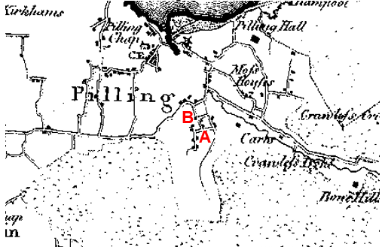
Observations |  | The map shows a network of lanes in the Pilling area between Pilling Moss and the sea. It shows a route that approximates to the application route as a 'cross road' from Lancaster Road to Bradshaw Lane. A route northwards from Point B to Head Dyke Lane is also shown in the same way.
Investigating Officer's Comments |  | A route approximating to the application route existed in 1786 and appeared to form a through route with a property shown to exist between point A and point B and a further property at point B.  To be shown on a map of this scale the route was probably physically more than a footpath in appearance.  The depiction of the route on this commercially produced small scale map suggests that the route was considered to be public highway and travellers using such a map were likely to be on horseback or horse-drawn vehicle.  There are however a number of inconsistencies shown on the map with a route shown extending from point B northwards which is not shown on any other map inspected and a watercourse is shown to the west of the application route along part of the alignment of Bradshaw Lane which casts some doubt over the accuracy of the map.
Greenwood’s Map of Lancashire | 1818 | Small scale commercial map. In contrast to other map makers of the era Greenwood stated in the legend that this map showed private as well as public roads and the two were not differentiated between within the key panel.
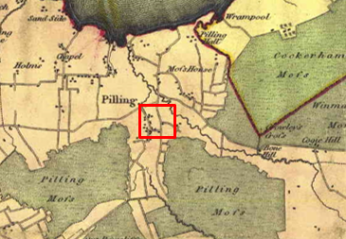
Observations |  | The map shows a route approximating to the application route as a cross road from Lancaster Road (Point A) to Point B and then northwards from point B continuing to Head Dyke Lane. The rest of the application route is not shown.
Investigating Officer's Comments |  | The application route existed between point A and point B. The route was probably physically more than a footpath in appearance and as the map was produced for the travelling public, it is likely that the route was a public one. Greenwood's map is too small-scale to show footpaths, and so if the rest of the application route existed only as a footpath in 1818 it is unlikely to be shown.
Hennet's Map of Lancashire | 1830 | A further small scale commercial map. In 1830 Henry Teesdale of London published George Hennet's Map of Lancashire surveyed in 1828-1829 at a scale of 7½ inches to 1 mile. Hennet’s finer hachuring was no more successful than Greenwood’s in portraying Lancashire’s hills and valleys but his mapping of the county's communications network was generally considered to be the clearest and most helpful that had yet been achieved.
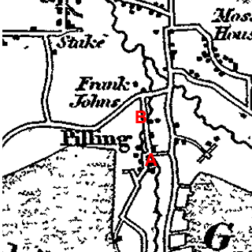
Observations |  | Hennet shows the application route as a cross road in the same was as Greenwood – as part of a longer through route from Lancaster Road to Head Dyke Lane. Properties are shown along the route and in the proximity of Bells Farm but the application route is not shown from point B eastwards. Ridgy pool is not shown on its current alignment although a watercourse is shown running roughly north–south crossing the application route in the vicinity of point B.
Investigating Officer's Comments |  | The route from Point A to B was probably physically more than a footpath in appearance.  Hennet's map is too small-scale to show footpaths, and so if the rest of the application route existed only as a footpath in 1830 it is unlikely to be shown.  As the only other category of 'road' shown on the map are the turnpike roads, it is possible that a cross road was regarded as either a public minor cart road or a bridleway (as suggested by the judge in Hollins V Oldham). It is unlikely that a map of this scale would show footpaths. Many properties are shown on this map with no access road or track to them. It is more likely that Hennet's map shows routes that were generally available to the travelling public in carts or on horseback and therefore suggests that between point A and point B the route was considered to be a public bridleway or carriageway.
Canal and Railway Acts |  | Canals and railways were the vital infrastructure for a modernising economy and hence, like motorways and high speed rail links today, legislation enabled these to be built by compulsion where agreement couldn't be reached. It was important to get the details right by making provision for any public rights of way to avoid objections but not to provide expensive crossings unless they really were public rights of way. This information is also often available for proposed canals and railways which were never built.
Observations |  | No railways or canals were built or are known to have been proposed in the area crossed by the application route.
Investigating Officer's Comments |  | No inference can be drawn.
Tithe Map and Tithe Award or Apportionment | 1845 | Maps and other documents were produced under the Tithe Commutation Act of 1836 to record land capable of producing a crop and what each landowner should pay in lieu of tithes to the church. The maps are usually detailed large scale maps of a parish and while they were not produced specifically to show roads or public rights of way, the maps do show roads quite accurately and can provide useful supporting evidence (in conjunction with the written tithe award) and additional information from which the status of ways may be inferred.
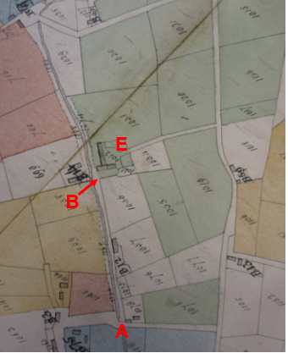
Observations |  | The application route between point A and point B is shown as a bounded track adjacent to a watercourse providing access to an unnamed building in the proximity of Brook Hall and continuing to point B. The track continues from point B northwards but is not shown to extend through to connect to Head Dyke Lane. It is not clear whether the route between point A and point B is included in a numbered plot but it is possible it was included in plot 1067 described as Boon Moss for which a tithe was payable. This plot was listed as being owned by E Hornby, John Gardner and Jane Bagot and occupied by Jane Bagot.  From point B there appears to be access to buildings forming part of a plot shaded green an numbered 1032 listed as being owned by E Hornby, John Gardner and Wm Bell Threlfall and occupied by Wm Bell Threlfall and described as House garden fold etc. with no tithe listed as being payable.  Between point B and point E access appears available past the buildings but not on the alignment of the route claimed. East of point E a bounded route continues through to Bradshaw lane which appears to form the main access to the farm.
Investigating Officer's Comments |  | The application route existed between point A and point B in 1845 and it may have been possible to pass through the farm between point B and point E to continue through to Bradhaw Lane. Whether this route was a public or private one in 1845 is not depicted in the tithe information.
Inclosure Act Award and Maps |  | Inclosure Awards are legal documents made under private acts of Parliament or general acts (post 1801) for reforming medieval farming practices, and also enabled new rights of way layouts in a parish to be made. They can provide conclusive evidence of status.
Observations |  | There is no inclosure award for this part of Pilling.
Investigating Officer's Comments |  | No inference can be drawn.
6 Inch Ordnance Survey (OS) Map | 1848 | The earliest Ordnance Survey 6 inch map for this area surveyed in 1844-45 and published in 1848.
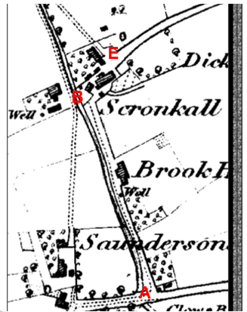
Observations |  | The application route is shown from point A to point B as a substantial bounded route providing access to Brook Hall and Skronkall. Access along it appears to be open and unrestricted by gates (which would normally be shown in a closed position). An unnamed watercourse is shown running parallel to the route (to the west).  Between point B and point E the application route appears to be available between the buildings named on the map as Scronkall. Two routes appear to be available through the farm – to the north and south of the largest building (which seems to share a similar footprint with the current building in that location) providing access through to point E. From point E a substantial bounded route continues east to Bradshaw Lane (now recorded as Footpath 19).  Buildings are shown where Bonds Farm is now located but there is no access to them via the application route and there does not appear to be a bridge across the watercourse (Ridgy Pool) close to Point B. Brookside Cottages not shown.
Investigating Officer's Comments |  | The application route existed between point A and point B in 1844-45 providing access to a number of properties. From point B it appeared possible to pass through Scronkall on the application route to point E.
25 Inch OS Map | 1890 | The earliest OS map at a scale of 25 inch to the mile. Surveyed in 1890 and published in 1893.
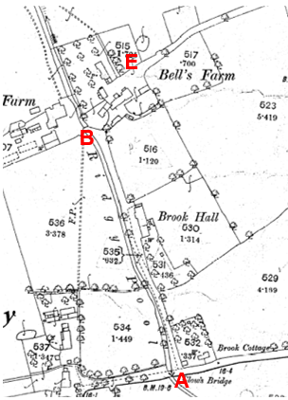
Observations |  | The first edition of the 25-inch map published in 1893 shows the complex of buildings of Bell’s Farm (Known as Scronkall on the 1st edition 6 inch map) in more detail.  The application route between point A and point B is clearly shown as an access road adjacent to Ridgy Pool providing access to Brook Hall. The route now also appears to provide the main access to Bond's Farm with a bridge over Ridgy Pool adjacent to point B.  Between point B and point E the collection of buildings and enclosures making up Bell's Farm are not as they are today although the route appears open from the access road at B passing through the farm to connect to point E. It is not possible to be sure whether there was a line across the route near B as the point where there may have been a gate or boundary is mostly obscured by a tree symbol on the map.
Investigating Officer's Comments |  | The application route from point A to point B and then from Point E along Public Footpath No. 19 Pilling to Bradshaw Lane are both clearly show as tracks or roads to named farms. The farm buildings and enclosures named on the map as Bell's Farm were not exactly as the layout today but it appears to have been possible to pass along the southern side of the farm from one track to another along the application route, possibly passing through one barrier east of point B. The map does not show if there was a gate or stile to allow people and/or farm traffic through it.
Finance Act 1910 Map | 1910 | The comprehensive survey carried out for the Finance Act 1910, later repealed, was for the purposes of land valuation not recording public rights of way but can often provide very good evidence. Making a false claim for a deduction was an offence although a deduction did not have to be claimed so although there was a financial incentive a public right of way did not have to be admitted.  Maps, valuation books and field books produced under the requirements of the 1910 Finance Act have been examined. The Act required all land in private ownership to be recorded so that it could be valued and the owner taxed on any incremental value if the land was subsequently sold. The maps show land divided into parcels on which tax was levied, and accompanying valuation books provide details of the value of each parcel of land, along with the name of the owner and tenant (where applicable).  An owner of land could claim a reduction in tax if his land was crossed by a public right of way and this can be found in the relevant valuation book. However, the exact route of the right of way was not recorded in the book or on the accompanying map. Where only one path was shown by the Ordnance Survey through the landholding, it is likely that the path shown is the one referred to, but we cannot be certain. In the case where many paths are shown, it is not possible to know which path or paths the valuation book entry refers to. It should also be noted that if no reduction was claimed this does not necessarily mean that no right of way existed.
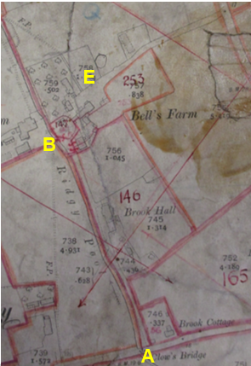
Observations |  | The Finance Act maps and valuation books were viewed at the Lancashire Record Office. None of the application route is excluded from the numbered plots. The application route lies within 3 taxable plots; between point A and the cottages near point B it is included as part of plot 146 listed as being owned by Margaret, Jane and Emily Elletson, Fox Ghyll, Ambleside and occupied by John Hodgson. The plot is described in the Schedule as 'House and Land' and no deductions are listed for public rights of way or user.  Between point B and point E the route crosses plots 147, 253 and 269. Plot 147 is also listed as being owned by Margaret, Jane and Emily Elletson and occupied by Thomas Hodgson. It is described as House/Bell's Farm and no deductions are listed for public rights of way or user.  Plot 253 is listed as being in the same ownership as plots 146 and 147 but is occupied by W and R Rossall. It is described as 'H and B' which is undefined but likely to be an abbreviated version of 'House and Barn'. No deductions are listed for public rights of way or user.  Plot 269 is listed in the ownership of EGS Hornby, Dalton Hall, Burton, Westmorland, Hannah Shepherd and William Shepherd, Pilling and is listed as being occupied by Hannah Shepherd. No deductions are listed for public rights of way or user.
Investigating Officer's Comments |  | It is normal to see an acknowledged public vehicular highway excluded from the numbered hereditaments as part of the process of compiling the taxation records and for ways considered to be public footpaths or bridleways at that time to be included in the numbered hereditaments for which a deduction may be claimed.  No part of the route is excluded from the numbered plots suggesting that it was not considered to be a public vehicular carriageway at that time and no deductions are claimed for the existence of public rights of way or user suggesting that the route was either not considered to be a public footpath at the time of the survey or that the landowners chose not to claim a deduction (plot 269 is crossed by routes recorded as public footpaths on the Definitive Map and Statement).
25 Inch OS Map | 1912 | Further edition of 25 inch map (surveyed 1890, revised in 1910 and published in 1912.
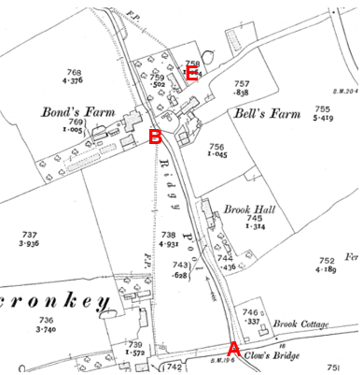
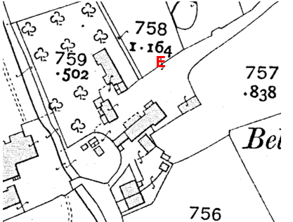
Observations |  | The 25-inch map published in 1912 shows some changes to the layout of buildings at the farm when compared with the 1893 edition. Brookside Cottages have been built (although not named on the map).  The application route is shown unaltered between point A and point B.  From point B to point E the application route is generally available along the route claimed. However, there is a line across the route between points C & D which may or may not have been a gate and wall of the building is not straight (there was a hint of this on previous maps but it is more pronounced on this.)  A strip of land has been left between the garden on the north-western side of No. 2 Brookside Cottages and a circular area of land fenced off adjacent to point B. This appears to provide access through to the rear of farm buildings at Bell's Farm.
Investigating Officer's Comments |  | The application route from point A to point B existed and may have been capable of being used. An enclosed strip of land about 3 metres wide which appears to correspond to the application route has been left alongside Brookside Cottage (not named on the map) garden which looks as if it may have been specifically provided to allow access to the farm buildings. There is a new small building beyond that with a gap between it and the main farm building, and then a barrier. It is not known if it was possible to pass through this barrier (if it was a gate for example) to get to the rest of the farm and join the access road at Point E. The wall of the main farm building is not straight so the application route may have been reduced in width towards point D or not adjacent to the wall at point C, it is not possible to distinguish between these within the tolerance of the mapping.
25 inch OS Map | 1932 | OS 25 inch map resurveyed in 1890, revised in 1930 and published 1932.
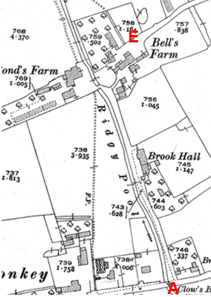
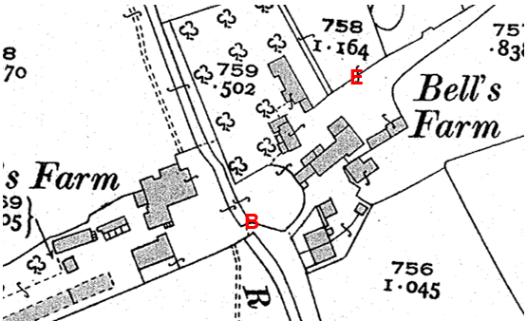
Observations |  | The 25-inch map revised in 1930 and published in 1932 shows further changes to the barns, sheds and outhouses at the farm, showing the OS map has been revised. Although some buildings have gone, and others have been built, the route through the farm is unchanged.  The access roads from Point A to Point B, and from point E eastwards are clearly shown, both unobstructed.
Investigating Officer's Comments |  | The application route from point A to point B existed and appeared to be capable of being used. There is still a route through the farm from Brookside Cottages if the barrier shown between two of the buildings is a gate or stile. However the application route may have been blocked or narrowed by the slight step-out in the line of the wall of the largest farm building.
Aerial Photograph | 1940s | The earliest set of aerial photographs available was taken just after the Second World War in the 1940s and can be viewed on GIS. The clarity is generally very variable.
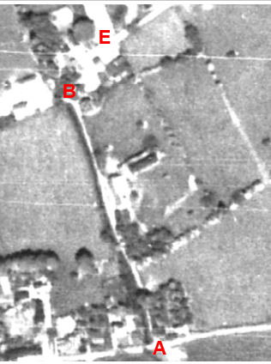
Observations |  | The application route between point A and point B can be clearly seen as a substantial track continuing past point B and over the watercourse (Ridgy Pool) to Bond's Farm.  Between point B and point E the application route cannot be seen. A track can be seen just south of point B which appears to provide access towards Bell's Farm from the application route but due to the poor quality of the photograph in the proximity to the buildings it is not possible to see whether this track provided access through the farm to point E.
Investigating Officer's Comments |  | The application route between point A and point B existed in the 1940s and appeared to be capable of being used. The application route between point B and point E could not be seen but a track leading off the route towards the farm just before point B is clearly visible and appeared to provide access to the farm – consistent with what is shown on the 1932 Ordnance Survey map.
6 Inch OS Map | 1955 | The OS base map for the Definitive Map, First Review, was published in 1955 at a scale of 6 inches to 1 mile (1:10,560). This map was revised before 1930 and is probably based on the same survey as the 1930s 25-inch map.
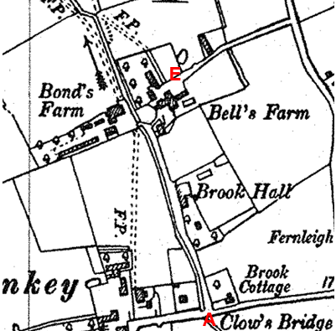
Observations |  | The 6-inch map published in 1955 shows the layout of the farm in the same way as the 1932 25-inch map. However, because of the reduction in scale some of the farm buildings are shown joined together and in a simpler form. The gap between the buildings described above is not shown on this map.  The access roads from Point A to B, and from point E eastwards are clearly shown, both unobstructed.
Investigating Officer's Comments |  | This map does not provide any additional information.
1:2500 OS Map | 1964 | Further edition of 25 inch map reconstituted from former county series and revised in 1962 and published 1964 as national grid series.
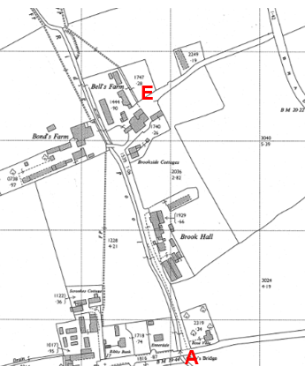
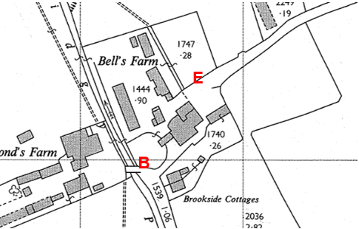
Observations |  | This edition of the 25-inch map published in 1964 shows further changes to the barns, sheds and outhouses at Bell's Farm. Some buildings have gone and a route through the farm is shown open and unobstructed with no barriers across it. As on earlier editions of the OS maps the application route from point A to point B is shown. The exact alignment of the route claimed between point B and point E may not be fully available close to point D.
Investigating Officer's Comments |  | The application route between point A and point B existed and appeared available to use. A route past Brookside Cottages and through Bell's Farm appeared to be available but may not be on the exact same alignment as the route claimed around point D.
Aerial photograph | 1960s | The black and white aerial photograph taken in the 1960s and available to view on GIS.
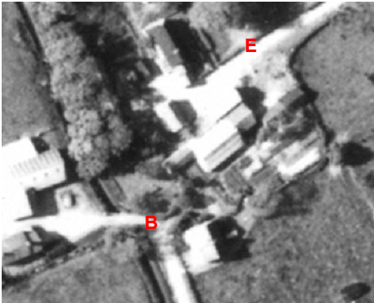
Observations |  | Part of the access road between points A and B is obscured by trees but most is shown and the route clearly provides access beyond point B to Bond's Farm.  A route just south of point B can be seen extending north east along a worn track to the north of Brookside Cottages towards Bell's Farm and appears to continue along the south side of a large building to exit across and open area to meet point E.
Investigating Officer's Comments |  | The application route between point A and point B existed in the 1960s and appeared to be capable of being used. A route from point B existed and may have provided access through to Point E but the existence of the whole route cannot be confirmed by using this photo.
Applicants submitted by the owners of 2 Brookside Cottages | 1988 | Photographs submitted by the owners of the property in objection to the application.
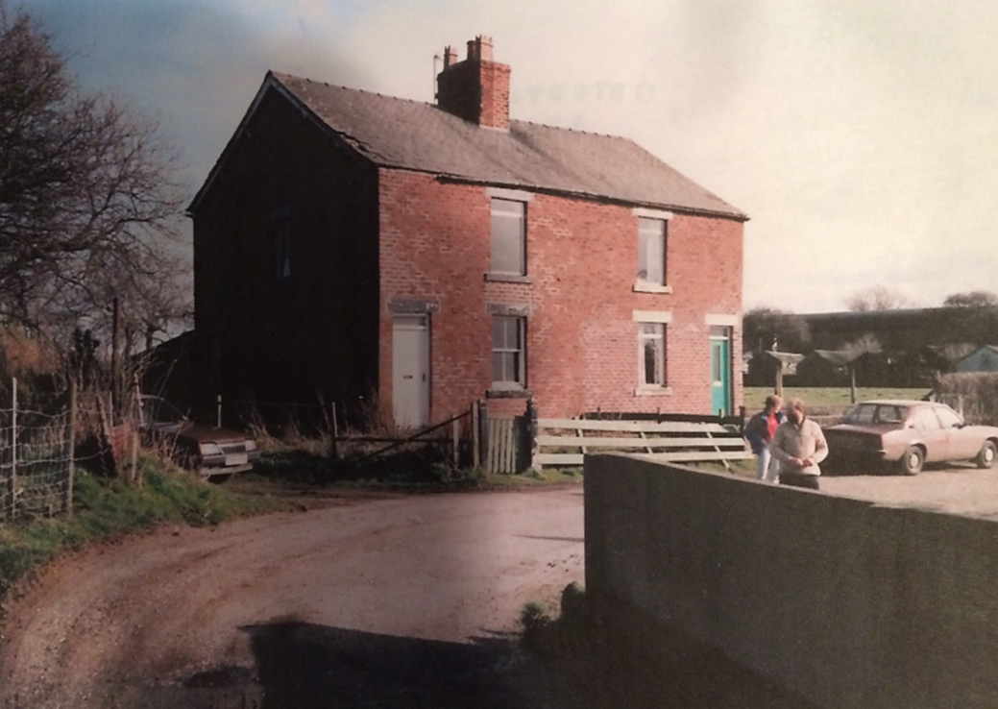
Photo 1
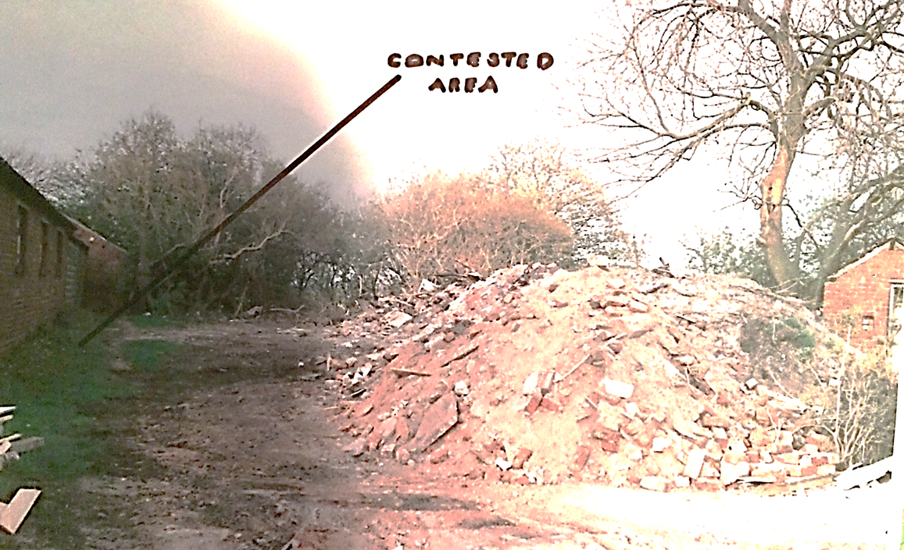
Photo 2
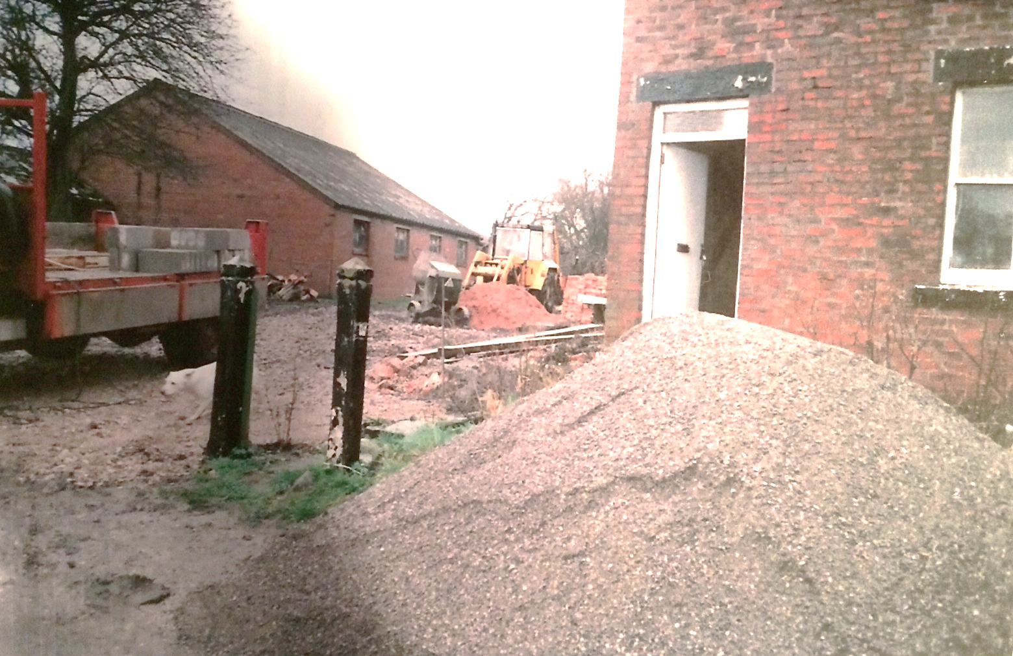
Photo 3

Observations |  | Photo 1 – is from the bridge looking east to point B. It clearly shows an entrance onto an area on which there is a parked car. It is not possible to see from the photograph whether this is the start of a track leading to Bell's Farm but its position is consistent with the track shown on the 1960s OS map.  Photo 2 – shows land between Primrose Cottage and Bell's Farm in the process of being cleared and redeveloped. It shows the land crossed by the application route between point C and point D.  Photo 3 – Shows how the area crossed by the application route was being redeveloped with the fencing shown on Photo 1 having been removed.
Investigating Officer's Comments |  | If all three photographs date from 1988 it suggests that extensive landscaping and redevelopment of the site was carried out around that time and the strip of land shown on the 1960s OS map and aerial photographs which appeared to provide access to Bell's Farm was altered. The photographs suggest that the application route may have been available.
Deed of Grant of Right of Way | 1989 | Copy of a Deed of Grant of Right of Way dated 4th May 1989
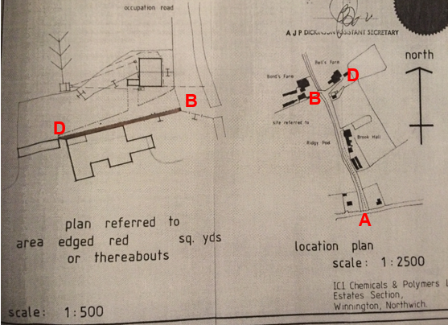
Observations |  | The plan forms part of a deed which grants a private right of way at Brookside Cottage Pilling along the application route between point B and point D.  The deed is dated 4th may 1989 and was made between Imperial Chemical Industries PLC and P Richardson and B. C. Richardson of Bell's Farm providing Mr and Mrs Richardson (and their successors in title) at all reasonable times in the day and by night a right to pass and repass on foot only over the access way coloured brown on the plan. The access way was described as being 4 foot 6 inches wide and the deed of access was stated as being for the purposes of the maintenance and repair of adjoining buildings.  The undated plan shows the access way as being consistent with the application route between point C and point D. there is no reference to the existence of a public footpath in the deed and part of the application route (between point A and point B) is shown labelled as an occupation road on the plan.  The plans show a wide access strip which lead from the application route at point B in an easterly direction to Bell's Farm. The access way granted as a private easement is shown along the most southerly edge of this strip of land.
Investigating Officer's Comments |  | The granting of a private right of access for the purpose of maintaining an adjacent building is not inconsistent with the existence of possible public rights.  The fact that the easement was granted around the time that the land was being redeveloped may however explain why the route to the farm – which was not recorded as a public footpath at that time -altered and a narrow fenced off path was provided, in part consistent with the one over which the owners of Bell Farm maintained a private right of access.
Aerial Photograph | 2002 | Aerial photograph available to view on GIS.
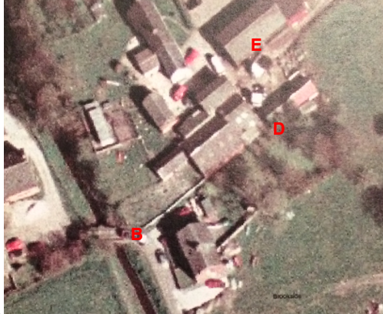
Observations |  | The application route between point A and point B can be seen. From point B a wall can be seen on the photograph extending in a straight line in a north easterly direction to the farm building. A grass strip can be seen adjacent to the wall but it is not possible to see from the photograph whether access was available along the application route through to point D. From point D there appears to be a gap between two buildings through which the application route passes but the route between point D and point E cannot be seen.
Investigating Officer's Comments |  | The photograph pre dates the submission of the application by 4 years. It appears that the route claimed between point B and point E may have been in existence at this time.
Plans relating to the redevelopment of Bell's Farm | 2003 | Plans relating to the conversion of Bell's Farm were found via an online search. The plans were submitted to Wyre Borough Council as part of the request for planning permission to redevelop the site.
Plan of Existing Site
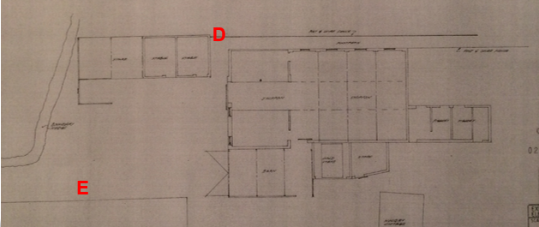
Plan of proposed development
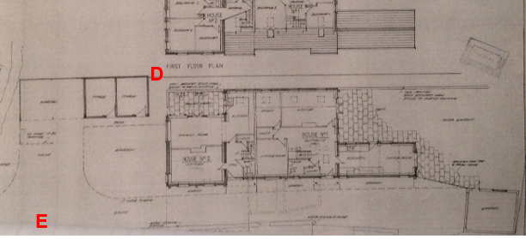
Observations |  | The plan showing the site layout as it existed in 2003 shows part of the application route between points B-C-D labelled as a footpath and bounded by post and wire fencing. A gap is shown in the buildings from point D and access appears available through to point E.  The plan of the proposed development still shows the application route from midway between points B-C and through to point D and access would be available from point D to point E. A wall is proposed to be built adjacent to the route between point B and point C.
Investigating Officer's Comments |  | The application route may have been available along the route claimed in 2003.
Aerial Photograph | 2006 | Aerial photograph available to view on GIS.
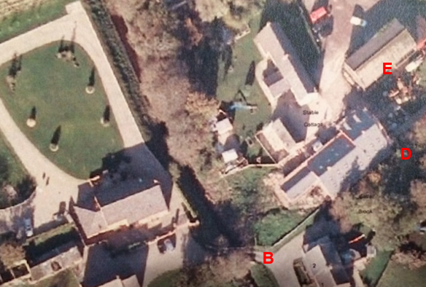
Observations |  | The application route between point A and point B is clearly visible. Primrose Cottages appear to have been renovated since the earlier aerial photograph taken 4 years earlier with a wide surfaced area to the north of the cottages and a strip of grass adjacent to a wall as far as point C. From point C it is not possible to see whether access is available due to tree cover. Neither is it possible to see whether access was available between point D and point E.
Investigating Officer's Comments |  | Parts of the application route existed in 2006.
Photographs submitted by the applicant | 1990-2008 | A number of photographs were submitted by the applicant to show the application route.
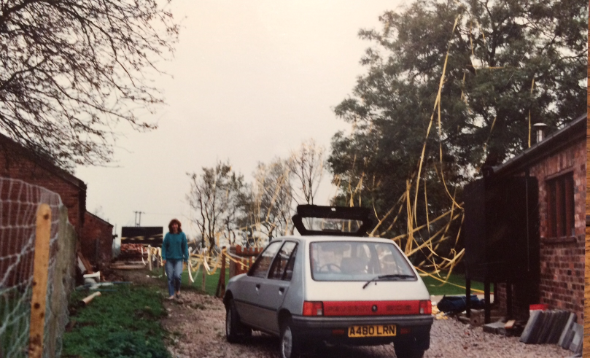
Photo 1 – approx. 1990

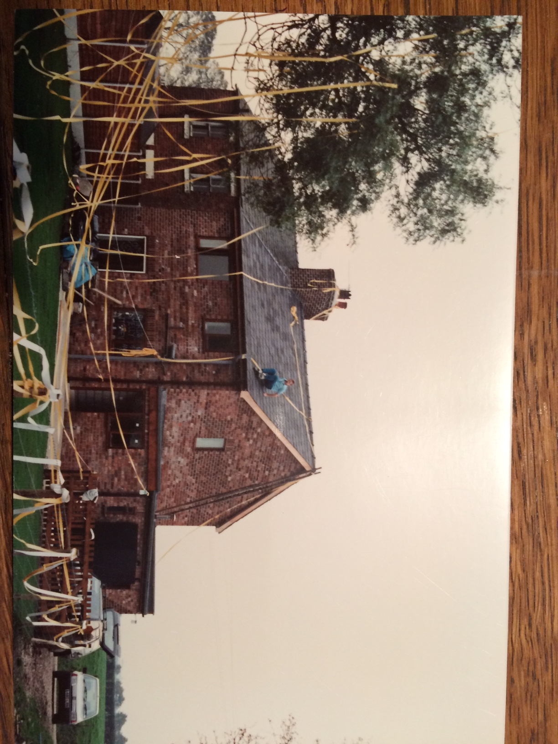
Photo 2 – approx. 1990

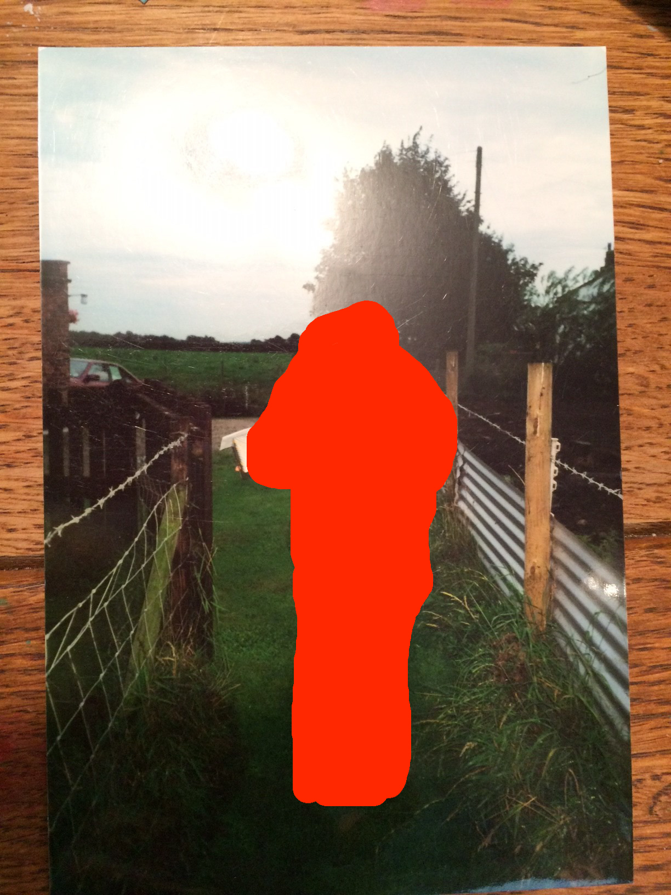
Photo 3 – approx. 1999
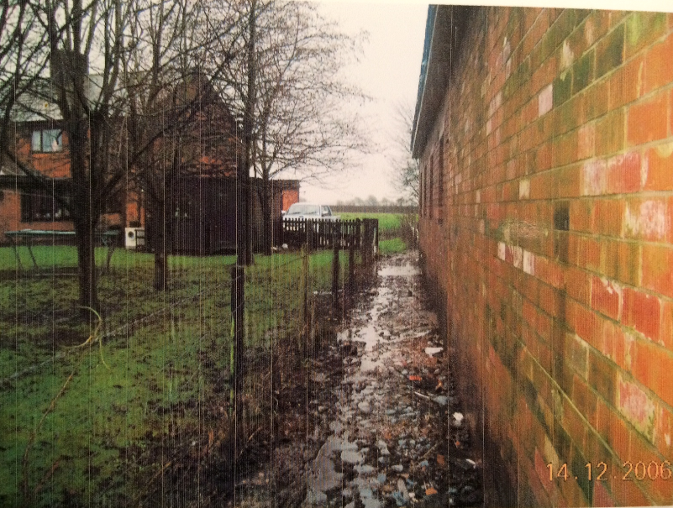
Photo 4 – 2006

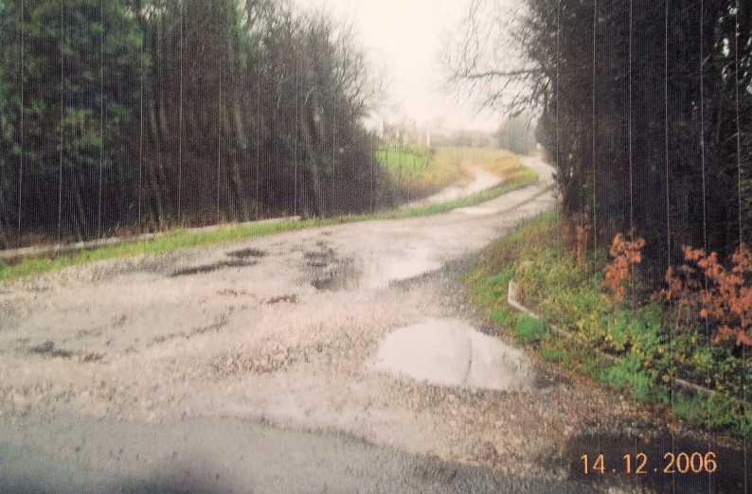
Photo 5 – 2006

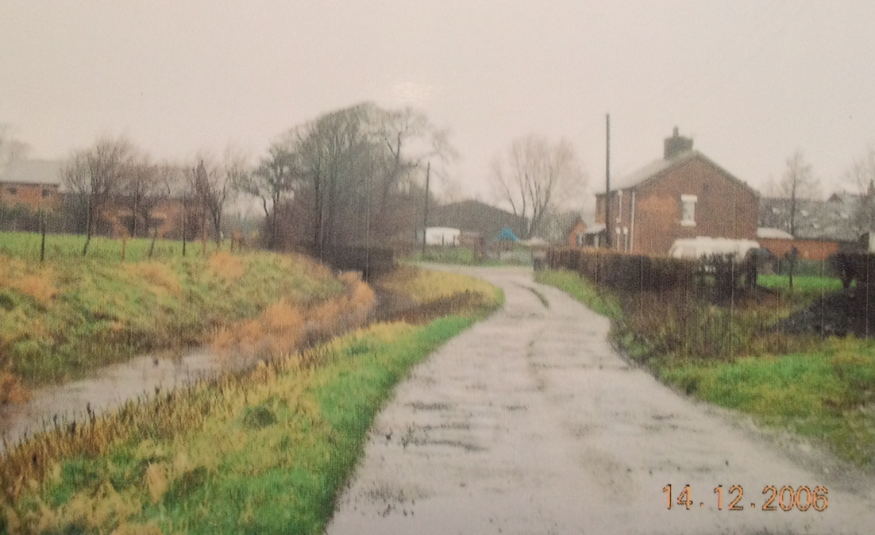
Photo 6 – 2008

Observations |  | Photos 1 and 2 – show Primrose Cottages in 1990. Both cottages appear to have been recently renovated and the fact that they are covered in streamers suggests some form of celebration. Photograph 1 shows the land crossed by the application route between point B and point C bounded by a post and wire fence. A route appears to be available through to point D and a person is present on the photograph walking the approximate route.  Photo 3 is dated approximately 1999 and shows a person stood on a grassy path fenced on either side by post and wire fencing now extending further towards the access road.  Photo 4 is dated 2006 (the year that the application was submitted) a fenced off pathway consistent with the application route between point B and point C. The surface is quite wet and churned up with evidence of pedestrian use.  Photo 5 shows the start of the application route in 2006 at point A as an open and accessible route.  Photo 6 shows the route approaching point B (2006).
Investigating Officers Comments |  | It is not possible to see from the photographs whether the application route was accessible along the entire route in 1990. The photographs indicate that the route was later fenced on both sides for much of the length between D and B.
Definitive Map Records |  | The National Parks and Access to the Countryside Act 1949 required the County Council to prepare a Definitive Map and Statement of Public Rights of Way.  Records were searched in the Lancashire Records Office to find any correspondence concerning the preparation of the Definitive Map in the early 1950s.
Parish Survey Map | 1950-1952 | The initial survey of public rights of way was carried out by the parish council in those areas formerly comprising a rural district council area and by an urban district or municipal borough council in their respective areas. Following completion of the survey the maps and schedules were submitted to the County Council. In the case of municipal boroughs and urban districts the map and schedule produced, was used, without alteration, as the Draft Map and Statement. In the case of parish council survey maps, the information contained therein was reproduced by the County Council on maps covering the whole of a rural district council area. Survey cards, often containing considerable detail exist for most parishes but not for unparished areas.
Observations |  | The parish survey map and cards were drawn up by Pilling Parish Council. The application route is not shown on the parish survey map or documented in the parish survey cards.
Draft Map |  | The parish survey map and cards for Pilling were handed to Lancashire County Council who then considered the information and prepared the Draft Map and Statement.  The Draft Maps were given a “relevant date” (1st January 1953) and notice was published that the draft map for Lancashire had been prepared. The draft map was placed on deposit for a minimum period of 4 months on 1st January 1955 for the public, including landowners, to inspect them and report any omissions or other mistakes. Hearings were held into these objections, and recommendations made to accept or reject them on the evidence presented.
Observations |  | The application route was not shown on the Draft Map of Public Rights of Way and there were no objections to the omission of the path.
Provisional Map |  | Once all representations relating to the publication of the draft map were resolved, the amended Draft Map became the Provisional Map which was published in 1960, and was available for 28 days for inspection. At this stage, only landowners, lessees and tenants could apply for amendments to the map, but the public could not. Objections by this stage had to be made to the Crown Court.
Observations |  | The application route was not shown on the Provisional Map and there were no formal objections or other comments about its omission.
The First Definitive Map and Statement |  | The Provisional Map, as amended, was published as the Definitive Map in 1962.
Observations |  | The application route was not shown on the First Definitive Map and Statement.
Revised Definitive Map of Public Rights of Way (First Review) |  | Legislation required that the Definitive Map be reviewed, and legal changes such as diversion orders, extinguishment orders and creation orders be incorporated into a Definitive Map First Review. On 25th April 1975 (except in small areas of the County) the Revised Definitive Map of Public Rights of Way (First Review) was published with a relevant date of 1st September 1966. No further reviews of the Definitive Map have been carried out. However, since the coming into operation of the Wildlife and Countryside Act 1981, the Definitive Map has been subject to a continuous review process.
Observations |  | The application route is not shown on the Revised Definitive Map and Statement of Public Rights of Way (First Review).
Investigating Officer's Comments |  | From 1953 through to 1966 there is no indication that the claimed route was considered to be public by the Surveying Authority, Parish Council and public at large due to the extensive consultation process that lasted until 1975 when the Definitive Map of Public Rights of Way (First Review) was actually published.
Highway Adoption Records including maps derived from the '1929 Handover Maps' | 1929 to present day | In 1929 the responsibility for district highways passed from district and borough councils to the County Council. For the purposes of the transfer, public highway 'handover' maps were drawn up to identify all of the public highways within the county. These were based on existing Ordnance Survey maps and edited to mark public. However, they suffered from several flaws – most particularly, if a right of way was not surfaced it was often not recorded.  A right of way marked on the map is good evidence but many public highways that existed both before and after the handover are not marked. In addition, the handover maps did not have the benefit of any sort of public consultation or scrutiny which may have picked up mistakes or omissions.  The County Council is now required to maintain, under section 31 of the Highways Act 1980, an up to date List of Streets showing which 'streets' are maintained at the public's expense. Whether a road is maintainable at public expense or not does not determine whether it is a highway or not.
Observations |  | The route is not recorded on the List of Streets and is not shown as an adopted highway on highway records retained by the County Council.
Investigating Officer's Comments |  | No inference can be drawn with regards to public rights.
Statutory deposit and declaration made under section 31(6) Highways Act 1980 |  | The owner of land may at any time deposit with the County Council a map and statement indicating what (if any) ways over the land he admits to having been dedicated as highways. A statutory declaration may then be made by that landowner or by his successors in title within ten years from the date of the deposit (or within ten years from the date on which any previous declaration was last lodged) affording protection to a landowner against a claim being made for a public right of way on the basis of future use (always provided that there is no other evidence of an intention to dedicate a public right of way).  Depositing a map, statement and declaration does not take away any rights which have already been established through past use. However, depositing the documents will immediately fix a point at which any unacknowledged rights are brought into question. The onus will then be on anyone claiming that a right of way exists to demonstrate that it has already been established. Under deemed statutory dedication the 20 year period would thus be counted back from the date of the declaration (or from any earlier act that effectively brought the status of the route into question).
Observations |  | No Highways Act 1980 Section 31(6) deposits have been lodged with the County Council for the area over which the application routes run.
Investigating Officer's Comments |  | There is no indication by a landowner under this provision of non-intention to dedicate public rights of way over their land.

The affected land is not designated as access land under the Countryside and Rights of Way Act 2000 and is not registered common land.

Landownership

The application route between point A and point B is owned by Mr and Mrs Marland, Bonds Farm, Scronkey, Pilling, Preston PR3 6SQ. Mr and Mrs Marland purchased the farm in 2013 and were not the landowners at the time of the application. The land registry title refers to the application route between point A and point B as an occupation road over which a right of access is granted to the owners of Primrose Cottages.

The owners of Bonds Farm prior to 2013 were Steven Pill and Beverly Highton who owned the farm at the time that the application was made.

The owners of the land crossed by the application route between points B-C-D are Mr and Mrs Wain, 2 Primrose Cottage, Scronkey, Pilling who have owned the land since 1989.

Between points D-E the land crossed by the application route is owned by Mr Peter Richardson and Mrs Beryl Richardson, Bells Farm, Bradshaw Lane, Pilling.

Summary

To summarise, the Investigating Officer was of the opinion that there was insufficient historical map and documentary evidence from which public rights could be inferred.

The earliest (1786) map examined shows a route, described in the key as a ‘cross road’ that corresponds to the application route, although the small scale of the map does not give details about the precise alignment or arrangement of buildings there. This route was shown to connect Lancaster Road and Bradshaw Lane.

This connection was again reflected in the Pilling Tithe map some 60 years later. Greenwood (1818) and Hennet (1830) though show only the application route from Point A to B, suggesting that if a link through did exist it wasn’t considered to be a public vehicular highway at that time. The Tithe map gives no indication about the status of the access tracks to Bonds Farm or to Bell's farms, and neither do the earlier published commercial maps of the county. It is more likely that commercial maps would have been produced for use by the travelling public, and through routes at least could be regarded as showing some kind of public status. The overall view of these maps is that it may have been possible to use a route in the mid 1800's on foot and horse-back between the two lanes. However, the depiction of the wider ‘cross road’ network in the area perhaps suggests that the application route was not one of the more important lanes in the parish, in contrast to the adjacent Lancaster Road, Bradshaw Lane and Head Dyke Lane, which are consistently shown in their recognisable modern alignments.

The access tracks to the farm from the south (the application route A – B) and east (Bradshaw Lane to Point E) are consistently shown on all maps without obstruction, and have clearly existed and been capable of being used since the late 1700s. However, the application route between point A and point B is not recognised as a public right of way on the Tithe Map, or as part of the Finance Act procedure and is labelled as an occupation road in land registry documentation.

From an inspection of the OS maps available, it appears that a route through Bell's Farm may have been available from at least the 1800s through to the late 1980s and other maps, plans and photographs suggest a route was still available in 2006.

Evidence of use submitted as part of the application dates from 2006 back to 1937.

During that time it is clear, looking at the various maps and aerial photographs, that a route may have been available to be used by the public between point A and point E, but that the route may have altered over time between point B-C-D.

A route through Bell's Farm appears to have been accessible from point B running to the north of 2 Primrose Cottage to point E and then through the farm buildings and across the farmyard to point E as shown on the 25 inch OS map published in 1964.

County Secretary and Solicitors Group Observations

Information from the Applicant

User Evidence

In support of the claim, the Applicant has submitted 32 evidence of use forms indicating knowledge of the route for 60-69 years (9); 50-59 years (4); 40-49 years (4); 30-39 years (3); 20-29 years (8); less than 10 years (3); and one unspecified period.

The forms indicate use of the route for 60-69 years (6); 50-59 years (3); 40-49 years (6); 30-39 years (2); 20-29 years (6); 10-19 years (2); less than 10 years (6); and one unspecified period. Two of the users who certify use of 20-29 years however have a private right of access over part of the claimed route and may be discounted.

Frequency of use varies from 5 times per year to daily, with 12 forms quoting a use of more than once a week. Usage has mainly been as a safe alternative to the road, which has dangerous bends and no pavement and carries fast-moving traffic. The route was used to access local facilities such as shops and Post Office, and other local communities, as well as leisure walking. 19 of the users have ridden bicycles along the route, one has ridden a horse, one a motor cycle/vehicle, and one has driven a horse and trap. Several can remember previous generations using the route and say that as children they were encouraged to use it as a safe route. One user refers to evidence of the route being wider in the past, although no details are submitted.

All the users certify that the way has always run over the same route, and have never seen any notices prohibiting or limiting access. All except one certify that they have never asked or been given permission to use the route, the sole exception having been given permission by Mrs Richardson. Although 29 users have never met any gates, stiles or fence obstructing the route, three say that there has been an occasional gate at Bell's Farm. One user reports having been stopped from using the route very occasionally when animals were being moved, but none of the other users report this.

Information from the Landowners

The land over which the claimed route runs is in three separate landholdings. The northernmost section is owned by Mr and Mrs Richardson of Bell's Farm. Mrs Richardson is the Applicant and Mr Richardson also writes in support of the claim. They also have a limited right of access by way of a private agreement over a further section of the claimed route.

This further section, between Brookside Cottages and Bell's Farm, runs over land owned by Mr and Mrs Wain of 2 Brookside Cottages. They have written at length, both privately and through their solicitors, in objection to the application. They claim that the Applicant is bringing the application to suit her own interests only and refer to it as a neighbour dispute. Whenever they have seen people walking across their land they have challenged them, and have had to erect gates at either end of their landholding, although no details of dates or whether the gates are locked are given. They refer to incidents when the police have been called to the scene because of youths behaving in an objectionable manner.

A letter written by Mr and Mrs Wain to the Parish Council and forwarded to Lancashire County Council makes the following points:-

- The claimed route has never appeared on any maps as a public right of way
- Mr Richardson is claiming that he owns the land in question “up to the trees”, which Mr and Mrs Wain themselves planted within their garden some years ago.
- A legal agreement dated 4th May 1989 between ICI and the occupants of Bell's Farm states that the claimed route is owned by 2 Brookside Cottages and the strip 4’6” wide is a maintenance strip for the occupants of Bell's Farm to maintain their property.
- Mr and Mrs Wain installed gates to protect their property, on the advice of their solicitors and of Lancashire County Council, but the gate was pushed over and had to be reinstated.
- There are already two public footpaths running through Scronkey and Mr and Mrs Wain do not see a need for any more.

A further letter from Mr and Mrs Wain expresses disbelief of the Evidence of Use forms submitted with the Claim. They call into question the veracity of the evidence and comment that they have never seen 18 of the witnesses use the claimed route since they moved in in 1989. Three live at Bell's Farm and use it by invoking private rights, and several others have now left the area. Mr and Mrs Wain also challenge the right of Mrs Richardson to give permission to use the route, as claimed by one witness. Since 1989, no-one has used the route without being challenged, with the exception of Ms Jones, their next door neighbour, who does not drive. Mr and Mrs Wain do admit however, that they cannot comment on usage prior to 1989. They believe that some 30 or 40 years ago there was a shop on Lancaster Road at the southern end of the route and suggest that perhaps an unofficial short cut developed purely as access to the shop.

Mr and Mrs Wain allege that when a planning application for development at Bell's Farm was made, the maintenance strip was included, as without it permission would not have been granted, as it is the only access to the rear of Bell's Farm. Mr and Mrs Wain were not properly consulted as owners and allege that if the application for a right of way is unsuccessful it will deeply affect the planning issues at Bell's Farm.

Mr and Mrs Wain have further supplied photographs showing the garden of 2 Brookside Cottages. The photographs date from 1988 when the cottage was being renovated and a fence and trees were put in place shortly afterwards, allowing space for private parking for 2 Brookside Cottages and honouring the maintenance strip granted to Bell's Farm.

Mr and Mrs Wain have planning permission to build an extension and are concerned that should the extension be built and the claimed footpath be accepted, there will be little room for them to park their vehicles. They also express concern about possible damage to their vehicles by people walking or congregating on the “maintenance strip”. The Committee will, of course, be aware that such submissions, whilst of importance to those persons making them, have no bearing on whether or not the path exists in law.

A further section of the route is in the ownership of Mr and Mrs Marland of Bonds Farm, which they purchased in 2014. The previous owners were Mr Pill and Ms Higton. Ms Higton contacted the County Council by telephone in April 2006 after being shown the copy of the application form and evidence supplied to Mrs Wain. She requested extra time to submit comments; however no such comments have been received.

Other adjoining landowners were consulted and one letter has been received in response, from Mr and Mrs S Richardson, whose land ownership directly abuts the section of the application route which runs to the north of 2 Brookside Cottages. They write in support of the claim and state that Mr Richardson has used the route for 30 years and Mrs Richardson since 1984. Their children have regularly used the route to visit a friend, and until recently they thought it was a public right of way.

Assessment of the Evidence

The Law - See Annex 'A'

In Support of the Claim

User evidence
No evidence of actual overt acts by the landowner
Available route historically

Against Accepting the Claim

Common law inference of dedication from historical map evidence is difficult leaving use as the important evidence to consider.

Conclusion

The claim is that the route has already become a footpath in law and should be
recorded on the Definitive Map and Statement.

There is no express dedication and so Committee is asked to consider the evidence
for deeming dedication under s.31 Highways Act 1980 or inference of dedication at
common law.

Taking first of all the inference of dedication at common Law. This requires sufficient evidence of an actual intention to dedicate by the owner. This can be from how the route was recorded on various documents or from circumstances such as user. Considering the historical map evidence it is suggested that there is insufficient historical map evidence from which public rights could be inferred from this but looking at the user evidence it would appear that no clear actions were taken by owners and use by the public continued over several years prior to 1989 such that on balance there may be sufficient evidence from which to infer dedication at common law.

Looking secondly at the provisions of s.31 Highways Act 1980 to consider whether the dedication can be deemed. The use to satisfy the statutory criteria has to be for twenty years immediately before the route was called into question. The route was called into question in 2006, this being the date of the application, the twenty years use to consider would be 1986-2006. Without further information about the alleged challenges since 1989, it is difficult to advise that the route was called into question any earlier. If however there was a calling into question at an earlier date there is still use of the route taking place back to 1940s.

The applicant has provided 33 user evidence forms which show use of the route from as early as on as 1940. The user forms suggest that, on balance, the route has been used as of right and without force, secrecy or interruption.

There have been numerous alterations to properties along the route. Number 2 Brookside Cottage was extended, Bells Brook and the Old Barn were also altered. Looking at the map in particular the OS map of 1964, this delineates a round field boundary which existed at Point B, this was removed it seems, in or around 1988/1989 when the building work was carried out to 2 Brookside Cottages and thereafter no longer existed. Brookside Cottage was extended further north during 1988/1989. The extension to Brookside Cottage narrowed the width that had been available in 1986. The alteration to the property, Bells Brook extended the building further towards Point D during the period under consideration.

A dedication under S31 cannot be deemed if changes to the route interrupt use or serve to indicate sufficiently an intention that the route is not a footpath.

If the claimed route is considered to have a width of 2m on this section, the claimed route had its width available throughout the changes around it. There is no evidence that use was interrupted and no evidence of a lack of intention to dedicate a public route.

On balance and after careful consideration, it is suggested that the criteria under s.31can be satisfied. Taking all the information into account the Committee may consider that a dedication of a footpath can be deemed or inferred and that it is appropriate that an Order be made and promoted to confirmation.

Risk Management

Consideration has been given to the risk management implications associated with this claim. The Committee is advised that the decision taken must be based solely on the evidence contained within the report, and on the guidance contained both in the report and within Annex 'A' included in the Agenda Papers. Provided any decision is taken strictly in accordance with the above then there is no significant risks associated with the decision making process.

Local Government (Access to Information) Act 1985

List of Background Papers

Paper | Date | Contact/Directorate/Tel
All documents on File Ref: 804-459
Reason for inclusion in Part II, if appropriate

N/A

The Ordnance Survey (OS) has produced topographic maps at different scales (historically one inch to one mile, six inches to one mile and 1:2500 scale which is approximately 25 inches to one mile). Ordnance Survey mapping began in Lancashire in the late 1830s with the 6-inch maps being published in the 1840s. The large scale 25-inch maps which were first published in the 1890s provide good evidence of the position of routes at the time of survey and of the position of buildings and other structures. They generally do not provide evidence of the legal status of routes, and carry a disclaimer that the depiction of a path or track is no evidence of the existence of a public right of way.
Aerial photographs can show the existence of paths and tracks, especially across open areas, and changes to buildings and field boundaries for example. Sometimes it is not possible to enlarge the photos and retain their clarity, and there can also be problems with trees and shadows obscuring relevant features.

